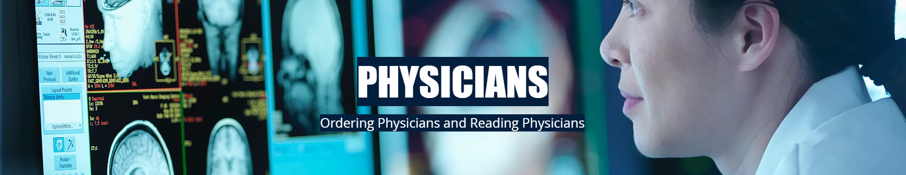

This site is under construction, but will direct physicians to a website where you will be able to view images and reports. We are very excited about the opportunity to serve our physicians better.

